*Florida International University*

*School of Computing and Information Sciences*

CIS 4911 - Senior Capstone Project

Software Engineering Focus

Feature Document

User Story # 669

**Team Member:**

Garrett Lemieux

**Product Owner(s)**:

Francisco Ortega

**Mentor(s)**:

Francisco Ortega

**Instructor**: Masoud Sadjadi

**User Story - Implement a Proximity Menu**

* As a User I would like to be able to use the Leap motion device to select different modes in order to allow for more interaction with UI.
* **Acceptance Criteria**:

1. User should be able to change modes by using proximity menu with leap motion device.
2. User should be provided feedback when proximity menu has updated application.

**Use Case: User Change draw setting with proximity menu**

User wants to be able to change draw settings with leap motion using a proximity menu.

* Details:
* Actor:
  + User
* Pre-conditions:
  + TouchPoint app is running.
  + Leap Motion is running.
* Description:
  + Use case begins when User has decided to change current applications draw setting or would like to save the current canvas.
  + User changes draw setting by performing gesture in specific quadrant of proximity menu.
    - Upper Right Quadrant – Saves image.
    - Upper Left Quadrant – Changes current drawing color.
    - Lower Left Quadrant – Changes current drawing shape.
    - Lower Right Quadrant – Turns proximity menu off.
  + Use case ends when user has been provided feedback from quadrant selected and draw setting has changed or image saved.
* Post-conditions:
  + After Upper Right Quadrant selected image must be in local machine.
  + After Upper Left Quadrant selected the color must be the new one in order.
  + After Lower Left Quadrant selected the next shape in order must be set as drawing shape.
  + After Lower Right Quadrant the proximity menu must not be shown or active.
* Decision Support:
  + Frequency: Medium, user may want to change modes using leap motion but could be forced to if it is the only devices connected.
  + Criticality: Medium, Other devices can change modes.
  + Risk: Medium
* Usability:
  + Need to understand how the leap motion gestures are performed
  + Need to know what function each gesture performs.
* Reliability
  + High
* Availability
  + Only available when leap motion device is connected.
* Performance
  + Performance High
  + Failure Low
* Supportability
  + Leap Motion Device
* Modification History:
  + Owner: Garrett Lemieux
  + Initiation Date 03/21/2016
  + Date last Modified: 04/03/2016

**Use Case Diagram**

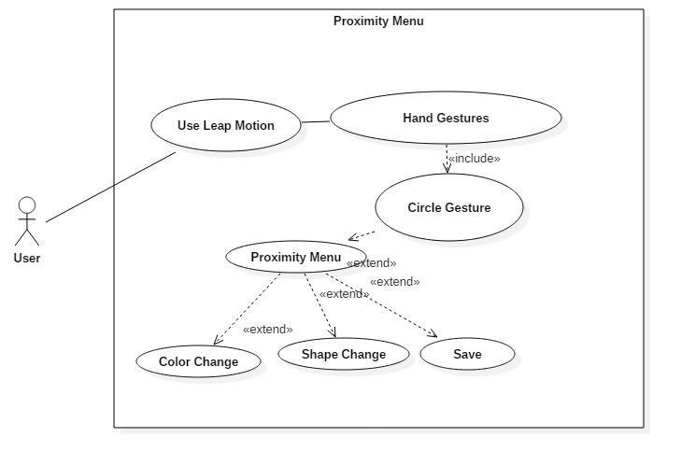

**Sequence Diagram**

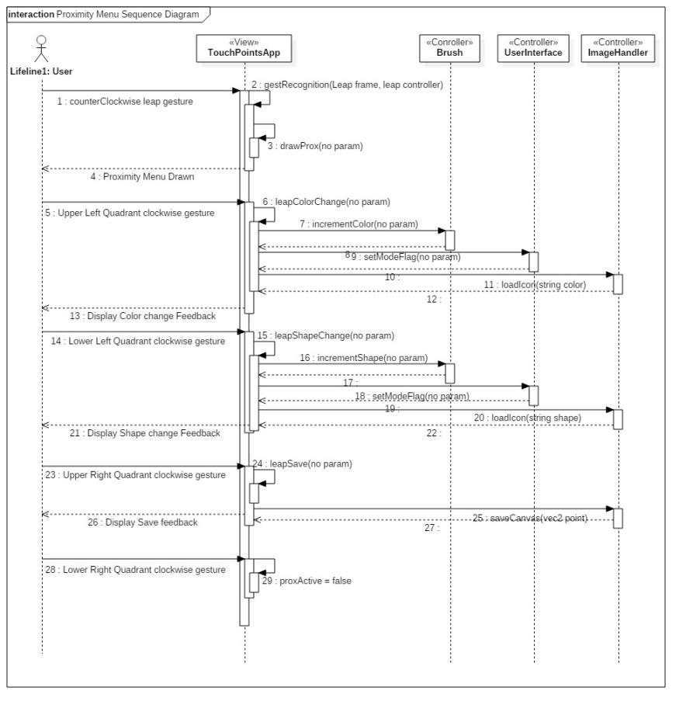

**Class Diagram**

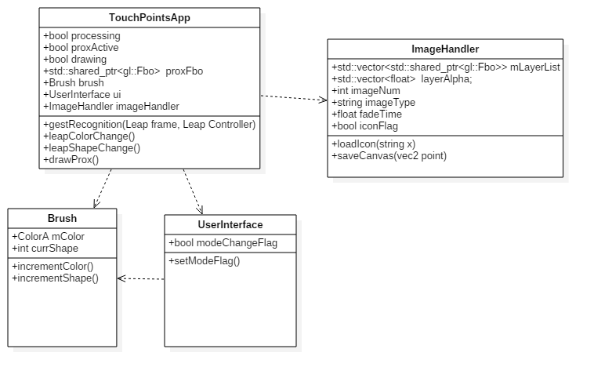

**Unit Test**

* Sunny Day Test:
  + Test Case  - Activate Proximity Menu
    - Test Purpose: To determine if user can turn on proximity menu.
    - Test Procedure: User starts program and then while in hover zone performs a counterclockwise circle gesture using leap motion.
    - Expected Results: Four quadrants appear on canvas.
  + Test Case  - Test if Upper Left-hand Quandrant is Activated
    - Test Purpose: To determine if user can select the Upper Left-hand quadrant in order to change current drawing color.
    - Test Procedure: After user has activated Proximity menu he or she moves finger while in hover zone into Upper Left-hand corner and performs a clockwise circle gesture using leap motion device.
    - Expected Results: Feedback should be given to user that color setting has changed.
  + Test Case  - Test if Upper Right-hand Quandrant is Activated
    - Test Purpose: To determine if user can select the Upper Right-hand quadrant in order to save the current canvas.
    - Test Procedure: After user has activated Proximity menu he or she moves finger while in hover zone into Upper Right-hand corner and performs a clockwise circle gesture using leap motion device.
    - Expected Results: Feedback should be given to user that canvas was saved.
  + Test Case  - Test if Lower Left-hand Quandrant is Activated
    - Test Purpose: To determine if user can select the Lower Left-hand quadrant in order to change current shape setting.
    - Test Procedure: After user has activated Proximity menu he or she moves finger while in hover zone into Lower-Left-hand corner and performs a clockwise circle gesture using leap motion device.
    - Expected Results: Feedback should be given to user that the current shape setting has changed.
  + Test Case  - Test if Lower Right-hand Quandrant is Activated
    - Test Purpose: To determine if user can select the Lower Right-hand quadrant in order to turn off proximity menu.
    - Test Procedure: After user has activated Proximity menu he or she moves finger while in hover zone into Lower-Right-hand corner and performs a clockwise circle gesture using leap motion device.
    - Expected Results: User should see the proximity menu disappear.
* Rainy Day Test:
  + Test Case  - User trys to turn on proximity menu using clockwise circular gesture
    - Test Purpose: Test if proximity menu can be turned on by accidently gesture.
    - Test Procedure: User starts program and attempts to turn on proximity menu by performing a clockwise circular gesture anywhere on the canvas. This procedure is repeated for all leap motion gestures.
    - Expected Results: Proximity menu should not appear. If proximity menu appears test fails.
  + Test Case  - User trys to select two quadrants at stame time
    - Test Purpose: Test if correct quadrant is selected.
    - Test Procedure: After user turns proximity menu on he or she enters hover zone and places finger location on line dividing any two quadrants. He or she then performs a clockwise circular gesture. The procedure is repeated for every combination of the four quadrants.
    - Expected Results: No feedback of any kind should be provided. If feedback provided then one of the quadrants was selected and test fails.

**Integration Testing**

* The ability to use the proximity menu while all devices are connected is successful. User may use proximity menu only with leap motion device.
* The proximity menu was used to save the canvas. After User chose quadrant that saves images the current canvas could be found on local machine.
* The proximity menu was used to change color setting for drawing on the canvas. After User chose quadrant that changes color setting both leap motion and multitouch device could draw with the new color.
* The proximity menu was used to change shape setting for drawing on the canvas. After User chose quadrant that changes shape setting both leap motion and multitouch device could draw with the new shape.
* After integrating proximity menu into the application all previous functionality was maintained and functioning correctly.

**User Guide**

* User must enter hover zone using leap motion device. Once in Hover zone user can perform a counterclockwise leap gesture to pull up proximity menu.

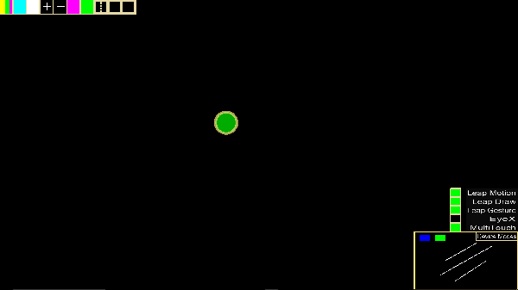

* Then he or she can change the current color setting by performing a clockwise gesture within in the middle of the upper left hand quadrant.

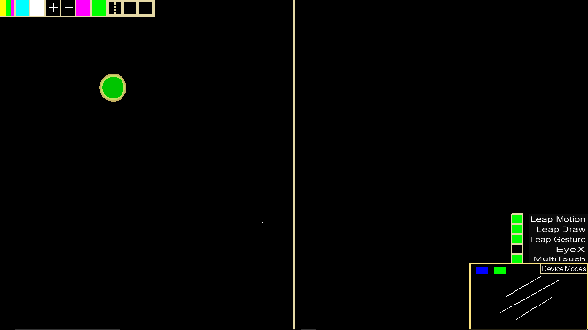

* Then he or she can change the current shape setting by performing a clockwise gesture within in the middle of the lower left hand quadrant.

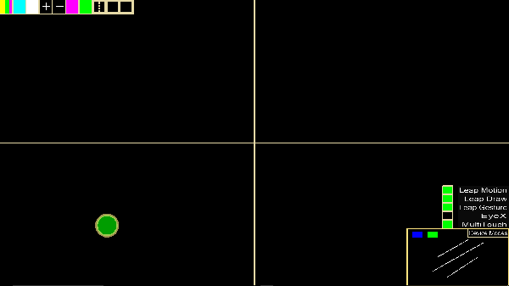

* Then he or she can save the canvas by performing a clockwise gesture within in the middle of the upper right hand quadrant.

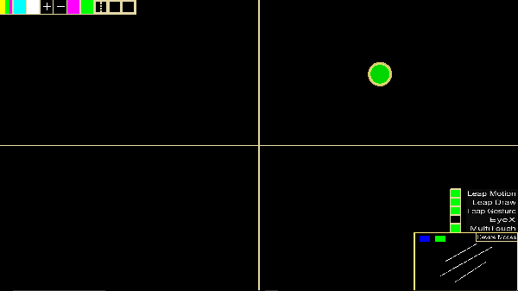

* Then he or she can exit the canvas by performing a clockwise gesture within in the middle of the lower right hand quadrant.

